Name : Sakshi Mohan Kamble PRN : 2020BTEIT00205

Course : Agile software tools and practices.

Assignment 1

Title:

Jira for Agile Practices/Methodology Methodology:

To create a project and team in Jira with roles, follow these steps:

1. Log in to Jira and select the "Create project" button.
2. Choose a project template (e.g. Scrum or Kanban) and customize the project details.
3. Invite team members to join the project and assign them roles such as Project Lead, Developer, or Tester.

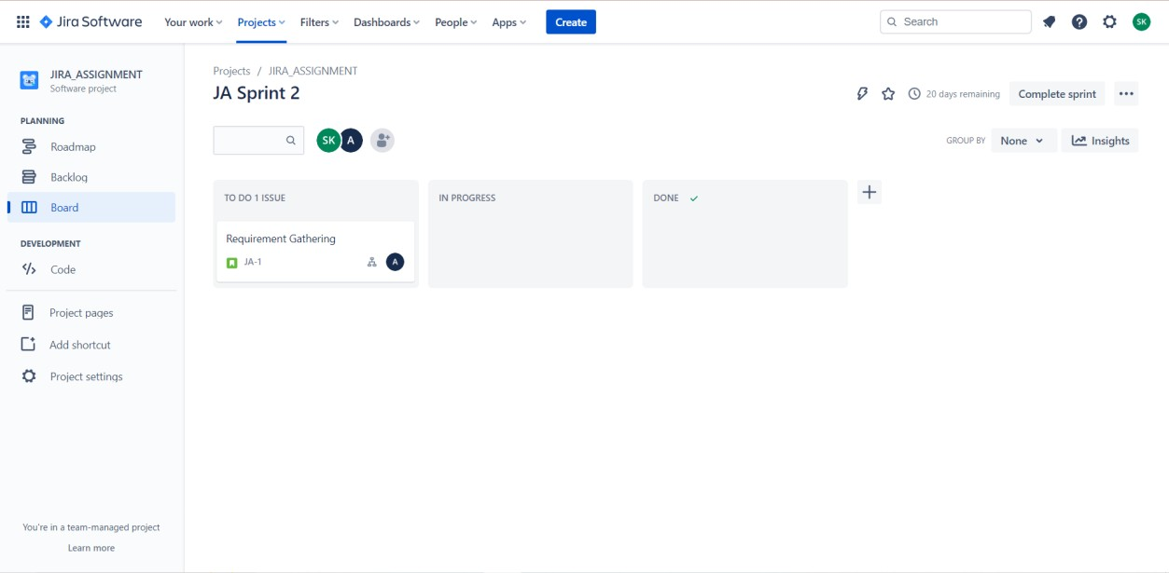

To add backlogs, issues, and tasks:

1. In the Project menu, select Backlog.
2. Create a new user story, issue, or task and assign it to a team member.
3. Add relevant details and subtasks to the item.

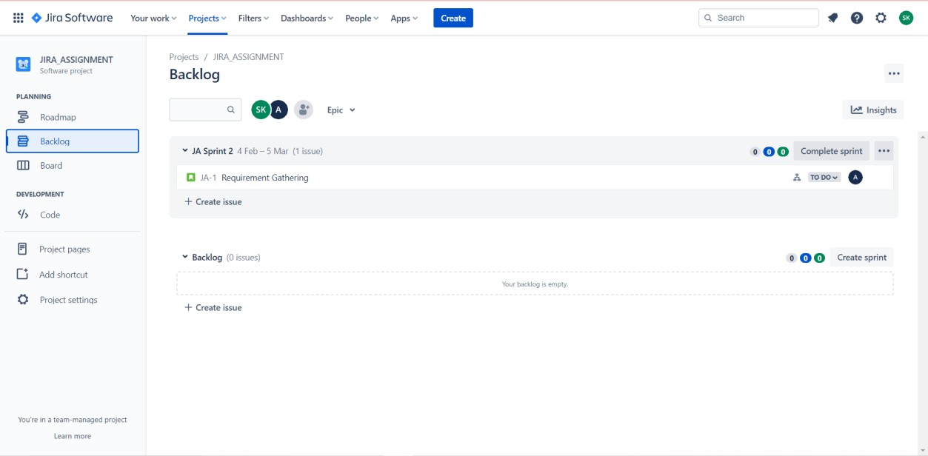

And here issues are created and assigned to members

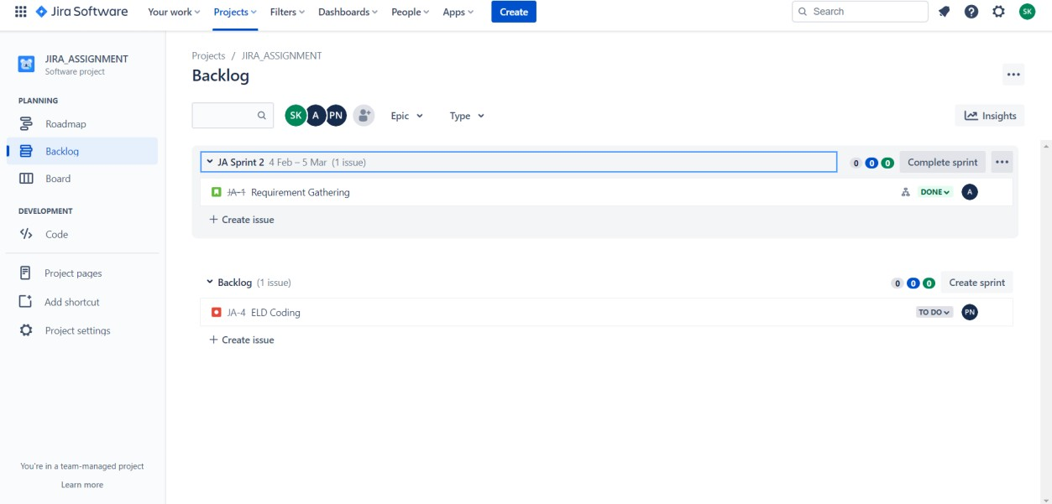

To track the work using scrum:

1. Enable scrum boards in the project and configure sprints.
2. Move items from the backlog to the "To Do" column of the sprint board.
3. Update the status of items as they move through the "In Progress" and "Done" columns.

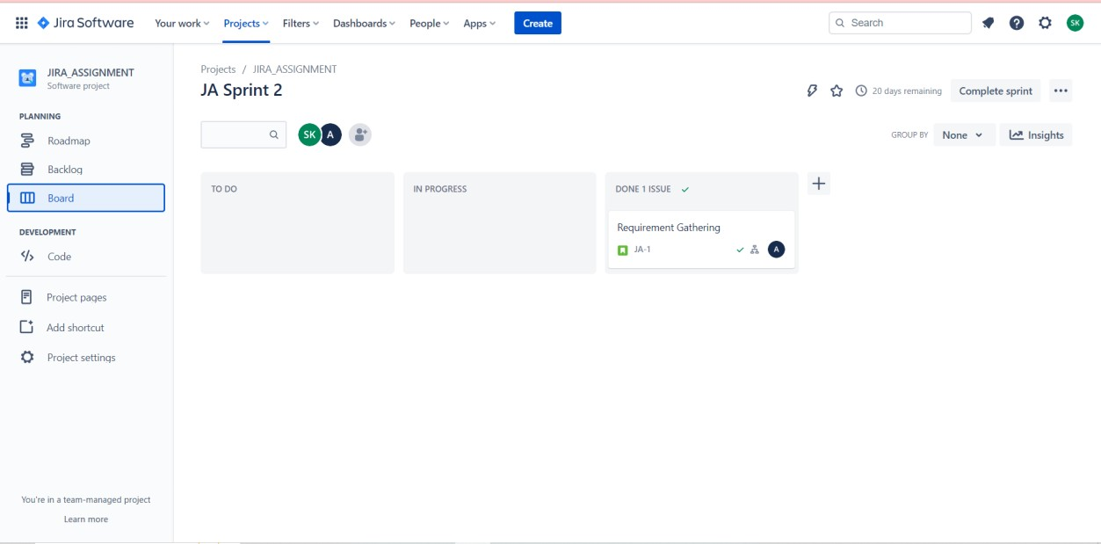

To integrate Github with Jira:

1. In Jira, go to the "Settings" and select "Applications."
2. Find the Github Integration and install it.
3. Connect your Github repository with your Jira project.
4. Enable repository linking in your project settings and add a link to your Github repository.

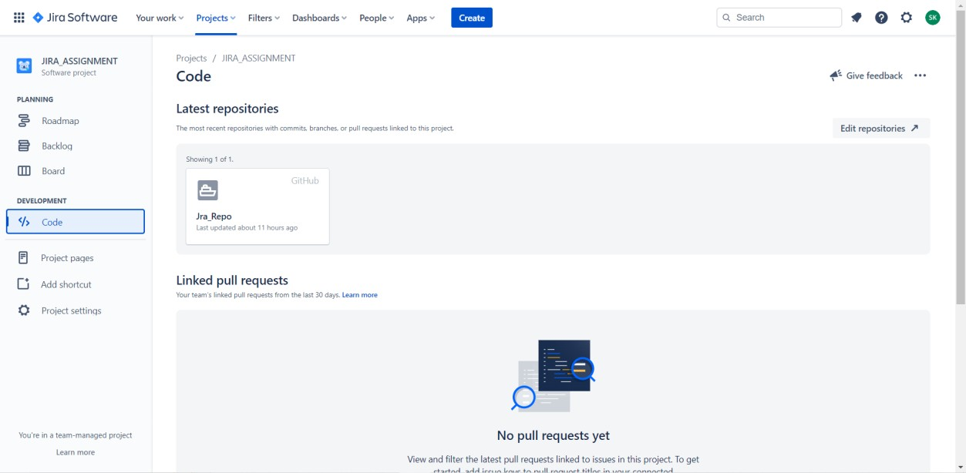

Jira is a powerful project management tool that allows teams to plan, track, and release software. It has a wide range of features, including backlog management, sprint tracking, reporting, and integrations with other tools like Github. The tool is highly customizable and can be adapted to meet the needs of any team or project.